3.4 Differentiability Worksheet
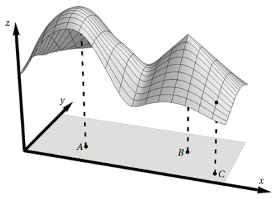
- Consider the function whose graph is shown at the right. Let A and B be points in corresponding to two “peaks” of the graph, and C be the point in corresponding to the dot on the graph. For each part, circle the answer that is the most consistent with the picture.

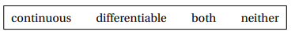
- At the point A, the function g is:


- At the point B, the function g is:

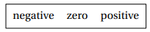
- At the point C, the function is:

- Show that is differentiable at .

We see that and .
We see that both functions are clearly continuous at all points therefore continuous at .
Therefore, we can conclude that is differentiable at the point .

- Show that is differentiable at

We see that and .
We see that both functions are not always continuous but are continuous at .
Therefore, we can conclude that is differentiable at the point .
- Consider the function .
- Confirm that the function is differentiable at the point .

We see that and .

We see that both functions are rational functions which clearly exist and are continuous at .

Therefore, we can conclude that is differentiable at the point .

- Confirm that the function is continuous at the point .

From part (a) we know that is differentiable at the point . This automatically implies that is continuous at the point .

Note: you could also check the continuity of at by using the definition of continuity, however this approach will take more work than using the important fact used above from section 3.4.

- Consider the function .
- Confirm that the function is differentiable at .

We see that and .
We see that both functions are not always continuous but are continuous at .
Therefore, we can conclude that is differentiable at the point .

- Confirm that the function is continuous at the point .

From part (a) we know that is differentiable at the point . This automatically implies that is continuous at the point .

Note: you could also check the continuity of at by using the definition of continuity, however this approach will take more work than using the important fact used above from section 3.4.

